IMDb Movie Analysis: An Interactive Power BI Dashboard

Submitted by: Abbas N, B.E. Computer Science and Engineering, Aalim Muhammed Salegh College of Engineering
Tools used: Microsoft Power BI Desktop, Power Query (M), Data Modelling
Date: November 2026

Abstract
This project analyses 700 highly rated films from IMDb, released between 1921 and 2026, to understand what characterizes critically acclaimed cinema. The raw CSV was loaded and reshaped in Power Query, where genre and country values were split into separate tables linked to the main table by film rank. The result feeds a single-page interactive dashboard of KPI cards, trend and distribution charts, a votes-versus-rating scatter plot, a top-films table and slicers.
The analysis shows that Drama appears in 473 of 700 films (68%), that the 2000s and 2010s supply half of the list (358 films), and that votes and ratings are moderately correlated (r = 0.41). Average rating falls from about 8.17 in the 1930s to 1950s to a low of 7.92 in the 2000s, then recovers to 8.06 in the 2020s. The report also documents the limits of the data: a rating floor of 7.5 and a country field that does not reflect true countries of origin.

Introduction
IMDb is one of the largest public film databases, and its user ratings are widely used as a shorthand for how audiences judge a film. A ranked list of top-rated films is a useful lens for studying taste: which genres audiences reward, which eras produced the most celebrated work, and whether popularity (vote count) tracks quality (rating).
The purpose of this project is to turn a flat table of 700 top-rated films into an interactive business-intelligence report. Instead of reading a spreadsheet row by row, a viewer can filter by genre, country or year and see every visual respond. The project also demonstrates an end-to-end analytics workflow: importing raw data, cleaning and reshaping it, modelling it, writing measures, choosing suitable visuals and drawing conclusions.

Problem Statement
The project sets out to answer the following questions using the data:
- How are the 700 top-rated films distributed across release years and decades?
- Which genres appear most often among top-rated films?
- How are IMDb ratings distributed, and how rare are the very highest scores?
- Is there a relationship between a film's rating and the number of votes it has received?
- Does film length relate to rating, and has average runtime changed over time?
- How has average rating changed from decade to decade?
- Which films, directors and actors recur most often in the list?

Dataset Description
The dataset is a single CSV file, imdb_dataset.csv, with 700 rows and 10 columns. Each row is one film. Ratings run from 7.5 to 9.3 and release years from 1921 to 2026.
Column | Data type | Description
Rank | Whole number | Position in the list (1 to 700)
Title | Text | Film title (699 unique titles)
Year | Whole number | Release year (1921 to 2026)
Genre(s) | Text | Up to three genres separated by "|" (22 distinct genres)
Director | Text | Director name (407 distinct directors)
Main Actor(s) | Text | Up to three lead actors separated by "|"
Country | Text | Two country codes per film, separated by "|" (see Limitations)
IMDb Rating | Decimal | Average user rating (7.5 to 9.3)
Votes | Whole number | Number of user votes (51,964 to 3,219,532)
Runtime (mins) | Whole number | Film length in minutes (68 to 321)
Headline figures: average rating 8.00, average runtime 127.4 minutes, average 533,097 votes per film and about 373.2 million votes in total.

Data Cleaning
The data was inspected for completeness, duplicates and structure before analysis.
Missing values. Only Main Actor(s) had gaps: 10 of 700 films (1.4%) have no billed cast. They are documentaries such as Senna, Inside Job, Free Solo, Blackfish and The Cove, and were left blank because they do not affect rating, votes or runtime analysis. Country has no missing values.
Duplicates. No rows are duplicated. One title appears twice, "The Girl with the Dragon Tattoo", but these are two different films (2009 and 2011), so both were kept. Rank, not Title, is therefore used as the unique key.
Transformations in Power Query.
- The CSV was imported, the first row promoted to headers, and each column given an explicit data type (whole number, decimal or text).
- A Decade column was added after the type change, using the formula Text.From(Number.IntegerDivide([Year], 10) * 10) & "s", which produces values such as 1990s and 2010s.
- Two reference queries were created from the main query: Genres (Rank and Genre(s)) and country (Rank and Country). In each, the pipe-delimited column was split by delimiter into rows.
- Splitting was done only in the reference queries, so the main imdb dataset table stays at 700 rows. Splitting inside the main table had earlier inflated it to about 1,890 rows and distorted every count and average, which is why the structure was rebuilt.
Result: imdb dataset has 700 rows, Genres has 1,823 rows (22 distinct genres) and country has 1,400 rows (19 distinct codes, exactly two per film).

Methodology
The project followed four stages.
1. Import and transformation (Power Query). The CSV was loaded into Power BI Desktop and shaped as described under Data Cleaning.
2. Data modelling. The model has three tables: imdb dataset (one row per film), Genres (one row per film-genre pair) and country (one row per film-country pair). Each lookup table is linked to the main table on Rank in a one-to-many relationship, with the main table on the "one" side. [CONFIRM: cross-filter direction set to Both] This lets a genre slicer filter every visual and lets genre counts reflect individual genres instead of combined strings.
3. Aggregation. The dashboard uses Power BI's built-in column aggregations, not custom DAX measures: a distinct count of Rank for the film total, averages for rating and runtime, a sum for votes, and the minimum and maximum of Year. Film counts by genre count the rows of the joined Genres table, so a film with three genres is counted once under each. [CONFIRM: if you also created DAX measures, list them here]
4. Visualisation. A single-page dashboard was built on a custom canvas with an IMDb logo and a black-and-gold palette. Slicers and cross-filtering between visuals provide the interactivity.

Dashboard:

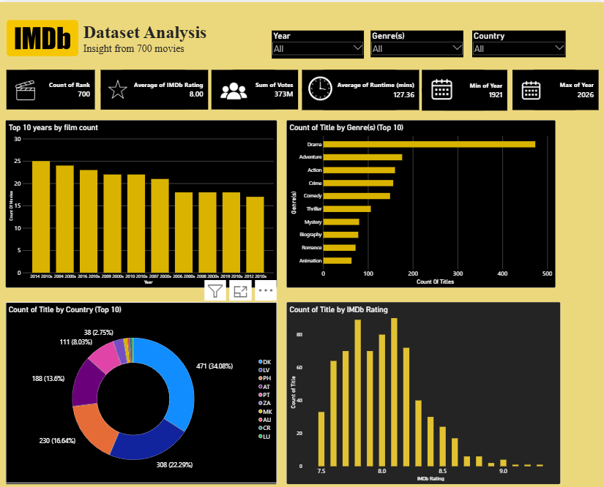
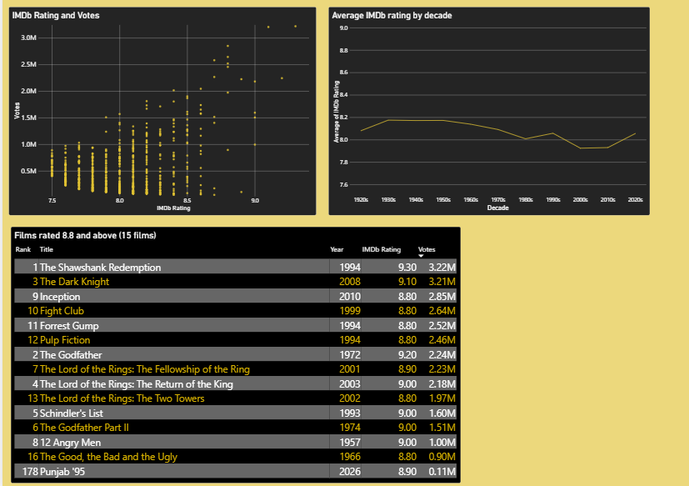
The dashboard is titled "Dataset Analysis: Insight from 700 movies" and reads from top to bottom.
Slicers. Year, Genre(s) and Country slicers filter the page. All three are built on columns of the main imdb dataset table, so the Genre(s) and Country slicers list the combined strings (for example Crime|Drama) instead of individual genres or countries.
KPI cards. Six cards show the film count (700), average rating (8.00), total votes (about 373 million), average runtime (127.4 minutes) and the earliest and latest release years (1921 and 2026).
Top 10 years by film count. A column chart of the ten busiest release years: 2014 (25 films), 2004 (24), 2016 (23), 2009 and 2010 (22 each), 2007 (21), then 2006, 2008 and 2019 (18 each) and 2012 (17). It is ranked by count, not by date, so it should not be read as a trend.
Top 10 genres. A bar chart counting films per individual genre, led by Drama (473 films).
Films by country code. A donut chart of the ten most frequent country codes as supplied in the source file. Each film carries two codes, so the slices add up to 1,400, not 700, and the codes do not match real production countries. Nothing in this report relies on this chart.
Rating distribution. A column chart counting films at each rating from 7.5 to 9.3, peaking at 8.1 (90 films) and 7.8 (89 films).
IMDb rating and votes. A scatter plot of all 700 films, with rating on one axis and votes on the other, showing the moderate positive relationship (r = 0.41).
Average IMDb rating by decade. A line chart of mean rating for each decade from the 1920s to the 2020s.
Films rated 8.8 and above. A table of the 15 films rated 8.8 or higher, showing rank, title, year, rating and votes, sorted by votes. It lists 15 rows, not 10, because six films tie at 8.8 and the Top 10 filter keeps ties.

Key Insights
1. Drama is the backbone of top-rated cinema. Counting each genre separately, Drama appears in 473 of 700 films (68%), ahead of Adventure (176), Action (160), Crime (156) and Comedy (149). Only 22 distinct genres appear in the whole list.
2. The 2000s and 2010s dominate. They contribute 177 and 181 films, 358 of 700 (51%). The busiest single years are 2014 (25 films), 2004 (24) and 2016 (23).
3. Ratings are tightly clustered and elite scores are rare. Because the list starts at 7.5, most films sit between 7.5 and 8.4. Only 62 films score 8.5 or higher (about 9%), 15 score 8.8 or higher, and 7 reach 9.0 or higher.
4. Popularity and quality are moderately linked. Votes and rating correlate at 0.41. The Shawshank Redemption leads on both: a 9.3 rating and 3.22 million votes. The Dark Knight (3.21 million) and Inception (2.85 million) follow on votes.
5. Longer films score slightly higher. Films over 180 minutes average 8.21 (30 films), compared with 7.94 for films of 90 to 120 minutes (275 films). The correlation between runtime and rating is weak (0.24), so this is a tendency, not a rule.
6. Average rating dips in the 2000s and 2010s, then recovers. Ratings are highest and steady from the 1930s to the 1950s (about 8.17), drift down through the 1970s and 1980s, bottom out at 7.92 in the 2000s and 7.93 in the 2010s, and rise to 8.06 in the 2020s. The correlation between release year and rating is -0.20. Much of this is a selection effect: older films appear on the list only if they are exceptional, while recent decades contribute many more films near the 7.5 floor.
Decade | Films | Average rating | Average runtime (min)
1920s | 5 | 8.08 | 97.2
1930s | 8 | 8.18 | 116.2
1940s | 14 | 8.17 | 115.2
1950s | 29 | 8.17 | 118.9
1960s | 31 | 8.14 | 134.6
1970s | 34 | 8.09 | 129.7
1980s | 61 | 8.01 | 121.0
1990s | 95 | 8.06 | 125.0
2000s | 177 | 7.92 | 126.6
2010s | 181 | 7.93 | 127.7
2020s | 65 | 8.06 | 143.2
7. Films are getting longer. Average runtime rises from 125.0 minutes in the 1990s to 143.2 minutes in the 2020s.
8. A small group of creators recur. Steven Spielberg has the most films (12), followed by Martin Scorsese (11), then Christopher Nolan, Quentin Tarantino and Stanley Kubrick (10 each). Robert De Niro (16 appearances), Leonardo DiCaprio and Tom Hanks (14 each) lead the lead-actor counts, where the data lists up to three leads per film.

Conclusion
Results. Top-rated films on IMDb are overwhelmingly dramas, concentrated in the last three decades, and rated within a narrow band just above 7.5. Audience popularity and ratings move together only moderately, long films hold a small edge in rating, and average rating dipped in the 2000s and 2010s before recovering in the 2020s. A three-table model lets the genre chart count individual genres correctly.
Limitations.
- Selection bias. Only films rated 7.5 or higher are included, so conclusions cannot be generalised to all films, and relationships such as rating against year are partly artefacts of how the list was built.
- Unreliable country field. The country codes do not match real production countries. For example, The Godfather and The Shawshank Redemption carry identical codes, and Spirited Away carries a different, unrelated pair. No country conclusions are drawn.
- Slicers use combined values. The Genre(s) and Country slicers are built on the main table, so they list combinations such as Crime|Drama and filter by the whole combination, not by individual genres.
- Rank is not a strict rating order. Punjab '95 has rank 178 but a rating of 8.9, so Rank appears to come from a separate weighting. The top-films table is filtered by rating and sorted by votes.
- Small early samples. The 1920s (5 films) and 1930s (8 films) are too small to support firm conclusions.
- No financial or critic data. Box office, budget and critic scores are absent, so success is measured only by user ratings and votes.
Future improvements.
- Point the Genre(s) and Country slicers at the split Genres and country tables so they list individual values.
- Obtain a corrected country-of-origin field and rebuild the country visual.
- Add a Director and an Actor lookup table, in the same way as Genres, to analyse individual people.
- Add a proper date table and DAX measures such as weighted rating and decade-over-decade change.
- Include lower-rated films to remove selection bias, and add budget and box-office data.
- Add drill-through pages for directors and actors, and publish the report to the Power BI Service.

